SOP- Image Processing Pipeline
Software
- Visual Studio Code
- Python
- Fiji
Procedure
- Quality control step: Run RawImageQC.py to examine raw .czi files.
  - Follow the "Running Python Scripts for Image Processing and Analysis - V1.0" SOP to run this Python script.
  - Ensure you are using the correct Python interpreter, “base (3.13.5)”
  - Click “Browse” to select the folder containing raw .czi files.
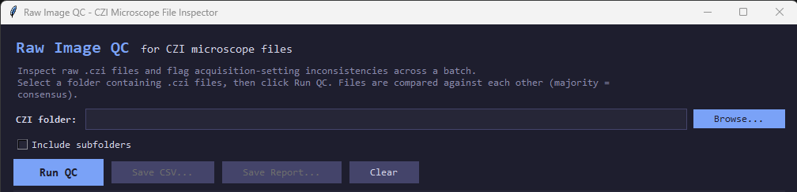
  - Click “Run QC” and allow script to fully run.
  - Once it is finished, click “Save CSV” and “Save Report” to save the full report to the same folder it was run on.
  - If any inconsistencies in the microscope settings are flagged, discuss how to handle this with your supervisor.
- Run Fiji macro on .czi files for pre-processing.
  - Open Fiji.
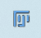
  - Select Plugins ⇒ Macros ⇒ Run…
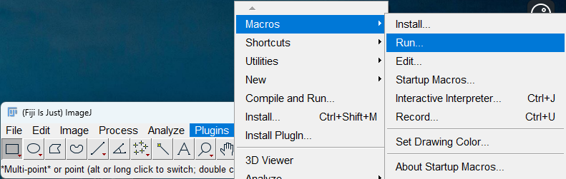
  - Navigate to the correct macro within "C:\Users\mileh\ImarisScripts\FijiMacros".
  - You will be prompted to select the folder where your .czi files are saved and then to select another folder where the processed images should be saved.
  - Let macro run until you see the final message confirming that the batch is complete.
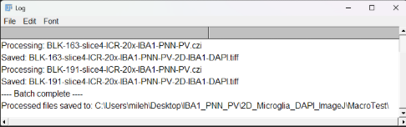
- Quality control step: Run PostProcessingQC.py to examine processed files.
  - Follow the "Running Python Scripts for Image Processing and Analysis - V1.0" SOP to run this Python script.
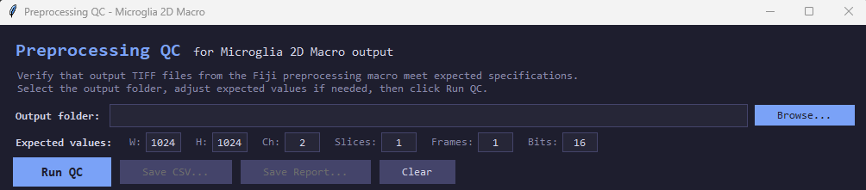
  - Change the values in the “Expected values” boxes to those consistent with your data.
  - Click “Browse” to select the folder you will be analyzing. Set this to the folder you output your processed files from the last step.
  - Click “Run QC” and allow script to fully run.
  - Once it is finished, click “Save CSV” and “Save Report” to save the full report to the same folder it was run on.
  - If any inconsistencies in the processed files are flagged, discuss how to handle this with your supervisor.
- IMPORTANT: If your files are tiff files and you plan to analyze them in Imaris, run tiff_to_ims.py to convert the files to .ims format. Note: This is essential, because the built-in Imaris TIFF Reader for our lab’s version of Imaris (v9.0.1) is dysfunctional.
  - Follow the "Running Python Scripts for Image Processing and Analysis - V1.0" SOP to run this Python script.
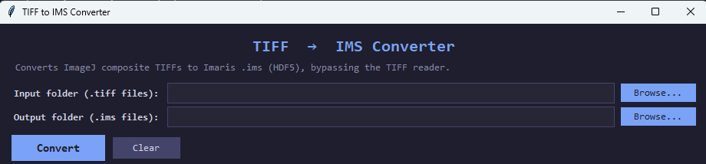
  - Select the correct input and output folders. Click “Convert.” Allow the program to run.

